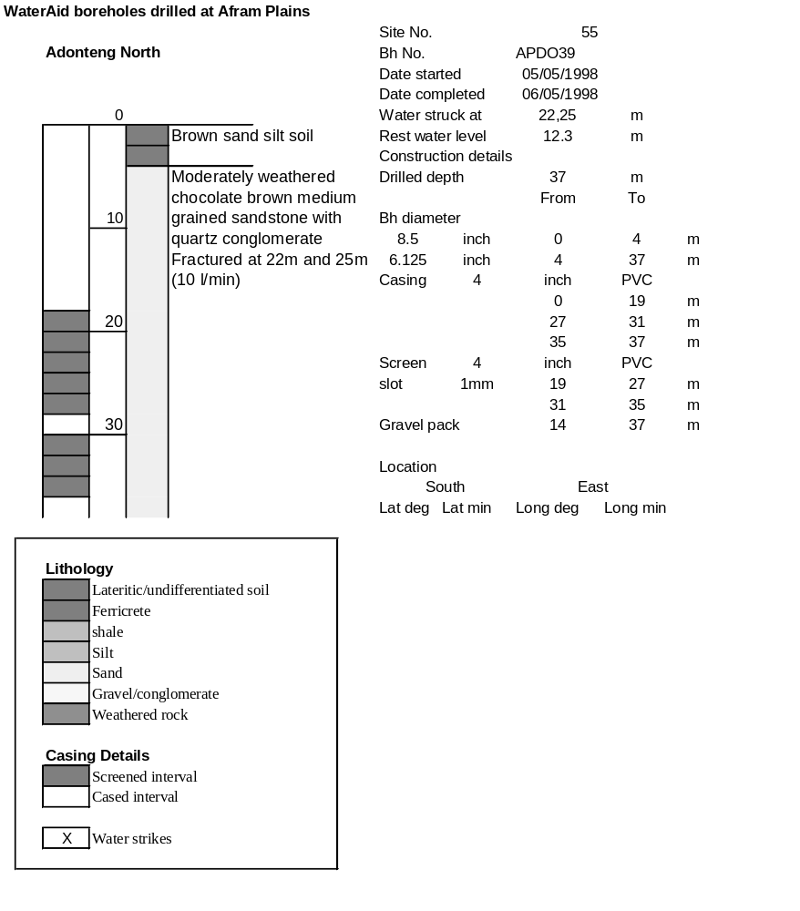

Ghana | Test pumping
Borehole No. |  | APDO39
Hole No |  | 55 | (5)
Village |  | Adonteng North
Date |  | 15/11/1998
Point above GL |  | 0.65 | m
Pump depth |  | 30 | m
SWL |  | 12.95 | m
Start Time |  | 09:20
Drawdown test |  |  |  |  | Recovery Test
time | pwl (m) | Q l/min | dd | sc(q/s) | Time | wl (m) | t/t' | resdd
0.00 | 12.95 | 10.00 | 0.00 |  | 0.00 | 15.32 |  | 2.37
1.00 | 14.10 | 10.00 | 1.15 | 8.70 | 1.00 | 14.27 | 241.00 | 1.32
2.00 | 14.20 | 10.00 | 1.25 | 8.00 | 2.00 | 13.67 | 121.00 | 0.72
3.00 | 14.38 | 10.00 | 1.43 | 6.99 | 3.00 | 13.35 | 81.00 | 0.40
4.00 | 14.48 | 10.00 | 1.53 | 6.54 | 4.00 | 13.16 | 61.00 | 0.21
5.00 | 14.56 | 10.00 | 1.61 | 6.21 | 5.00 | 13.07 | 49.00 | 0.12
6.00 | 14.61 | 10.00 | 1.66 | 6.02 | 6.00 | 13.03 | 41.00 | 0.08
7.00 | 14.66 | 10.00 | 1.71 | 5.85 | 7.00 | 13.00 | 35.29 | 0.05
8.00 | 14.67 | 10.00 | 1.72 | 5.81 | 8.00 | 13.00 | 31.00 | 0.05
9.00 | 14.68 | 10.00 | 1.73 | 5.78 | 9.00 | 12.99 | 27.67 | 0.04
10.00 | 14.69 | 10.00 | 1.74 | 5.75 | 10.00 | 12.99 | 25.00 | 0.04
12.00 | 14.70 | 10.00 | 1.75 | 5.71 | 12.00 | 12.99 | 21.00 | 0.04
14.00 | 14.70 | 10.00 | 1.75 | 5.71 | 14.00 | 12.98 | 18.14 | 0.03
16.00 | 14.68 | 10.00 | 1.73 | 5.78 | 16.00 | 12.98 | 16.00 | 0.03
18.00 | 14.78 | 12.00 | 1.83 | 6.56 | 18.00 | 12.98 | 14.33 | 0.03
20.00 | 14.90 | 12.00 | 1.95 | 6.15 | 20.00 | 12.98 | 13.00 | 0.03
25.00 | 15.17 | 12.00 | 2.22 | 5.41 | 25.00 | 12.97 | 10.60 | 0.02
30.00 | 15.20 | 12.00 | 2.25 | 5.33 | 30.00 | 12.97 | 9.00 | 0.02
35.00 | 15.22 | 12.00 | 2.27 | 5.29 | 35.00 | 12.97 | 7.86 | 0.02
40.00 | 15.22 | 12.00 | 2.27 | 5.29 | 40.00 | 12.97 | 7.00 | 0.02
45.00 | 15.23 | 12.00 | 2.28 | 5.26 | 45.00 | 12.97 | 6.33 | 0.02
50.00 | 15.24 | 12.00 | 2.29 | 5.24 | 50.00 | 12.96 | 5.80 | 0.01
55.00 | 15.24 | 12.00 | 2.29 | 5.24 | 55.00 | 12.96 | 5.36 | 0.01
60.00 | 15.24 | 12.00 | 2.29 | 5.24 | 60.00 | 12.96 | 5.00 | 0.01
70.00 | 15.25 | 12.00 | 2.30 | 5.22 | 70.00 | 12.96 | 4.43 | 0.01
80.00 | 15.26 | 12.00 | 2.31 | 5.19 | 80.00 | 12.96 | 4.00 | 0.01
90.00 | 15.27 | 12.00 | 2.32 | 5.17 | 90.00 | 12.96 | 3.67 | 0.01
100.00 | 15.27 | 12.00 | 2.32 | 5.17 | 100.00 | 12.96 | 3.40 | 0.01
110.00 | 15.27 | 12.00 | 2.32 | 5.17 | 110.00 | 12.96 | 3.18 | 0.01
120.00 | 15.28 | 12.00 | 2.33 | 5.15 | 120.00 | 12.96 | 3.00 | 0.01
130.00 | 15.29 | 12.00 | 2.34 | 5.13
140.00 | 15.30 | 12.00 | 2.35 | 5.11
150.00 | 15.30 | 12.00 | 2.35 | 5.11
160.00 | 15.30 | 12.00 | 2.35 | 5.11
170.00 | 15.31 | 12.00 | 2.36 | 5.08
180.00 | 15.30 | 12.00 | 2.35 | 5.11
190.00 | 15.30 | 12.00 | 2.35 | 5.11
200.00 | 15.31 | 12.00 | 2.36 | 5.08
210.00 | 15.31 | 12.00 | 2.36 | 5.08
220.00 | 15.31 | 12.00 | 2.36 | 5.08
230.00 | 15.32 | 12.00 | 2.37 | 5.06
240.00 | 15.32 | 12.00 | 2.37 | 5.06

